EXERCISE 6 - Element-wise array multiplication with strip mining
Files : strip_serial.c, strip_parallel.c
(N = 1 000 000, C[i] = A[i] * B[i])
Compile / run
gcc -O2 -fopenmp strip_serial.c -o strip_serial && ./strip_serial
gcc -O2 -fopenmp strip_parallel.c -o strip_parallel && OMP_NUM_THREADS=4 ./strip_parallel

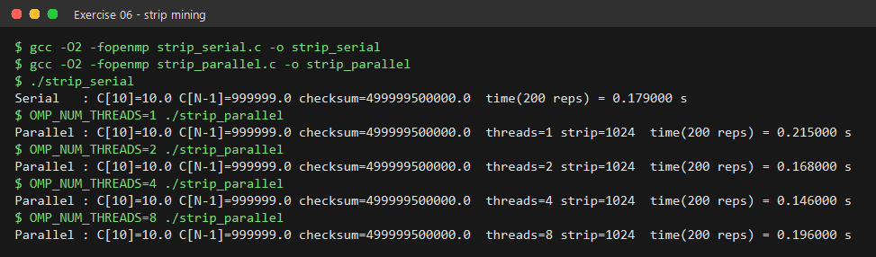
Strip mining
The single loop 0..N-1 is split into two loops:

#define STRIP 1024 // multiple of the SIMD width

#pragma omp parallel for schedule(static) // strips shared between threads
for (int i = 0; i < N; i += STRIP) {
int end = (i + STRIP < N) ? i + STRIP : N; // clamp the last strip
#pragma omp simd // strip itself is vectorised
for (int j = i; j < end; j++)
C[j] = A[j] * B[j];
}

* OUTER loop walks the array one strip at a time - OpenMP distributes
these strips across the threads.
* INNER loop processes one strip - a short, fixed-length loop the
compiler turns into SIMD instructions.
* Strip size 1024 floats: a multiple of both the AVX2 width (8 floats)
and the AVX-512 width (16 floats), so every strip maps onto whole
vector registers; 4 KB per strip also fits comfortably in L1 cache.

Results
Checksum is identical in every run (499999500000). The kernel is repeated
200x to get a measurable time. Speed-up is small because a
1-FLOP-per-element multiply is limited by MEMORY BANDWIDTH, not by
compute - a couple of threads already saturate it.

